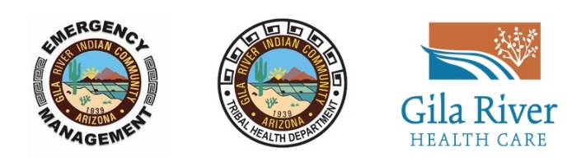
Gila River Indian Community COVID-19 Task Force

DEPARTMENT, BUSINESS, ENTITY & ORGANIZATION RECOVERY GUIDANCE

This recovery guidance shall establish and explain the necessary policies, practices and conditions necessary to meet the Centers for Disease Control and Prevention (CDC), Arizona Department of Health Services (ADHS) and Gila River Indian Community guidelines and standards. The plan should have the strong commitment of management and be developed and implemented with the participation of employees. The Community’s COVID-19 Task Force may provide technical guidance when requested but the plan approval when required will be via the following;

Community Departments: Office of Community Manager
Businesses, Entities and Organizations: Oversight Authority

COVID-19 Task Force Contacts for Departments, Businesses, Entities and Organizations:

GRIC Departments Liaison | Kathyleen Curley | Kathyleen.Curley@gric.nsn.us | 520-610-0607
Community Enterprise Liaison | Manuel Johnson | mjohnson@wildhorsepass.com | 480-272-4077
Task Force ESF #14, Business Recovery | David White | dwhite@wildhorsepass.com | 480-404-0698

Your COVID-19 Preparedness Plan must include and describe how your business will implement at a minimum the following:

- Infection prevention and housekeeping measures
- Employee, customer and visitor screening
- Engineering and administrative controls for social/physical distancing
- Employee, customer & visitor controls and protections for drop-off, pick-up and delivery
- Legal considerations for operating during the COVID-19 pandemic
- Communications and training for managers and workers necessary to implement the plan
- Provision of management and supervision necessary to ensure effective ongoing implementation of the plan

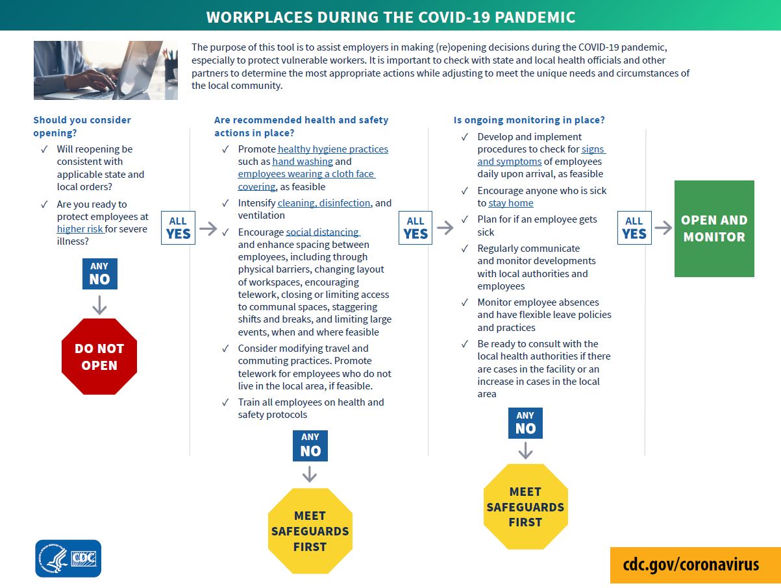
[link to the above decision tree]
COVID-19 Resources:
Gila River Indian Community Resources  - GRIC Community Updates (including Exec Orders)  - GRIC Emergency Operations Center (Situation Room/Plans)  - Gila River Health Care Updates  Arizona Resources  - Arizona Executive Orders  - Re-Opening Guidance Releases  - Arizona Department of Health Services  - Guidance On Screening of Visitors | Center for Disease Control & Prevention (CDC)  - Interim Guidance for Businesses and Employers  - Communities, Schools, Workplaces & Events  - Preparing Your Small Business  - Cleaning & Disinfecting Your Facility  - Cleaning & Disinfecting Your Vehicles  - Business F&Q  - Handwashing Information  - Handwashing Video  Occupational Health & Safety Administration (OCHA)  - Guidance on Preparing Workplaces

Note: The Gila River Indian Community COVID-19 Task Force does not provide approval for any plan.
COVID-19 Preparedness Plan for [department, business, entity, organization]

This template is provided as an example for your business or entity only

[department, business, entity, organization] is committed to providing a safe and healthy workplace for all our workers [and customers/visitors]. To ensure we have as safe and healthy workplace, we have developed the following COVID-19 Preparedness Plan in response to the COVID-19 pandemic. Managers and workers are all responsible for implementing this plan. Our goal is to mitigate the potential for transmission of COVID-19 in our workplaces and communities, and that requires full cooperation among our workers [and] management [and customers/visitors]. Only through this cooperative effort can we establish and maintain the safety and health of our workers and workplaces.

Management and workers are responsible for implementing and complying with all aspects of this COVID-19 Preparedness Plan. [department, business, entity, organization] managers and supervisors have our full support in enforcing the provisions of this policy.

Our workers are our most important assets. We are serious about safety and health and keeping our workers working at [department, business, entity, organization]. Worker involvement is essential in developing and implementing a successful COVID-19 Preparedness Plan. We have involved our workers in this process by [Describe how worker concerns have been addressed, how worker suggestions and feedback have been requested, and how such suggestions have been integrated into developing the plan].

Our COVID-19 Preparedness Plan follows Centers for Disease Control and Prevention (CDC), the Arizona Department of Health Services (ADHS), the Gila River Indian Community Tribal Health Department (GRIC THD) guidelines, local and federal OSHA standards related to COVID-19, all Gila River Indian Community Executive Orders and addresses:

- Section 1: Infection prevention and housekeeping measures
- Section 2: Employee, customer and visitor screening
- Section 3: Engineering and administrative controls for social/physical distancing
- Section 4: Employee, customer & visitor controls and protections for drop-off, pick-up and delivery
- Section 5: Legal considerations for operating during the COVID-19 pandemic
- Section 6: Communications and training for managers and workers necessary to implement the plan
- Section 7: Provision of management and supervision necessary to ensure effective ongoing implementation of the plan

Interim Guidance for Businesses and Employers
https://www.cdc.gov/coronavirus/2019-ncov/community/guidance-business-response.html

Section 1: Infection Prevention & Housekeeping

[Describe how your department, business, entity, organization will ensure proper infection prevention measures and housekeeping]

- Resource: CDC Prevention
https://www.cdc.gov/coronavirus/2019-ncov/prevent-getting-sick/prevention.html
- Resource: CDC Handwashing
https://www.cdc.gov/handwashing/when-how-handwashing.html
- Resource: CDC Coughing & Sneezing
https://www.cdc.gov/healthywater/hygiene/etiquette/coughing_sneezing.html
- Resource: CDC Face Coverings
https://www.cdc.gov/coronavirus/2019-ncov/prevent-getting-sick/diy-cloth-face-coverings.html
- Resource: CDC Guidance for Cleaning and Disinfecting
https://www.cdc.gov/coronavirus/2019-ncov/community/clean-disinfect/index.html

Section 2: Screening

[Describe how your department, business, entity, organization will ensure employee, customer and visitor health screenings]

- Resource: CDC Symptoms of Coronavirus
https://www.cdc.gov/coronavirus/2019-ncov/symptoms-testing/symptoms.html?CDC_AA_refVal=https%3A%2F%2Fwww.cdc.gov%2Fcoronavirus%2F2019-ncov%2Fabout%2Fsymptoms.html
- Resource: CDC What to Do If You Are Sick
https://www.cdc.gov/coronavirus/2019-ncov/if-you-are-sick/steps-when-sick.html
- Resource: GRIC IAP Section- Employee Screening & Sick Employee Guidance
https://www.gric-eoc.org/gric-iap.html

Section 3: Physical Distancing

[Describe how your department, business, entity, organization will ensure physical distancing standards]

- Resource: CDC Recommendations
https://www.cdc.gov/coronavirus/2019-ncov/prevent-getting-sick/social-distancing.html

Section 4: Employee, Customer & Visitor Controls & Protections

[Describe how your department, business, entity, organization will ensure employee and customer controls and protections for general work settings, drop-off, pick-up and delivery]

- Research your industry best practices
- Resource: GRIC IAP Section- PPE Optimization Guidance
https://www.gric-eoc.org/gric-iap.html
- Personal Protective Equipment (PPE) will be at the expense of the business and/or enterprise
https://www.cdc.gov/coronavirus/2019-ncov/prevent-getting-sick/diy-cloth-face-coverings.html

Section 5: Legal Considerations

[Describe how your department, business, entity, organization will address any legal considerations of operating during the pandemic]

- Legal council will be at the expense of the business and/or enterprise

Section 6: Communications and Training

This COVID-19 Preparedness Plan was communicated [explain how] to all workers [date] and necessary training was provided. Additional communication and training will be ongoing [explain how] and provided to all workers who did not receive the initial training. Instructions will be communicated to customers and visitors about: how drop-off, pick-up, delivery and in-store shopping will be conducted to ensure physical distancing between customers and workers; required hygiene practices; and recommendations that customers and visitors use face masks when dropping off, picking up, accepting delivery or in-store shopping. Customers and visitors will also be advised not to enter the workplace if they are experiencing symptoms or have contracted COVID-19.

Section 7: Implementation of the Plan

Managers and supervisors are to monitor how effective the program has been implemented by [explain how]. Management and workers are to work through this new program together and update the training as necessary. This COVID-19 Preparedness Plan has been certified by [department, business, entity, organization] management and was posted throughout the workplace [date]. It will be updated as necessary.

Certified by: [signature] [title]

Checkpoints for Business Operations During COVID-19

- Do I have a COVID-19 Preparedness Plan?
- Do I have an effective COVID-19 Testing Plan for essential employees if applicable?
- Do I have an appropriate PPE supply chain to support my plan?
- Do I have sufficient legal protection to support operations during COVID-19?
- Do I have an effective Self-Monitoring Program for my plan?

Notes:

[End Document]

